## horizontal line



Kokomo Summer Festival

17.02.2016.

# Takeshi Unicorns

Tagwoa Paul

K. A. Van den Berkmortel

Simon C. Onumajuru

Jose Guerrero Ferrer

Alexander Kotsev

# Table of Contents

Takeshi Unicorns 0

Prefaces 2

Client 2

Processes 2

Functional requirements 2

Decisions and arguments 2

User Interface 3

Takeshi Unicorns 0

Table of Contents 1

Prefaces 2

Client 2

Processes 2

Functional requirements 2

Decisions and arguments 2

User Interface 3

# Prefaces

This website is aimed at advertising and attracting visitors for the *Kokomo Summer Festival*. Which will take place at the Molecaten Park Kuierpad in Eindhoven. We are not targeted only on making this festival known but also focused on inspiring other companies for creativity, innovation, imagination and ideas. Hope you enjoy as well as we took time to make this Kokomo Summer Festival happen.

# Client

Mr Stevens, from Amsterdam, Netherlands wants us to create a website particularly for a party in which young peoples of age 18+ can attend and in which we will have many events taking place, users can reserve a tent at the camping site, also this event has to take place for a maximum of 3 days starting from Friday until Sunday, to be advertised through the social media, and also for registering the event through the website Kokomo festival.

# Processes

The event will be hosted on the website created by Takeshi Unicorns. The main aim is to attract as many people as possible to the Kokomo Summer Festival taking place on a weekend for 3 days. The targeted group is young people from 18 years old. They can either get their entrance ticket from the gate itself through a self-portal machine or they can go to the website and buy their ticket through registering on the web, and then pay for their tickets. They get a confirmation screen form after registration and then after deciding which days they will be attending and select from different types of events in the website of which they can pay with a choice of secure payment and refund which will cost 3 euros plus the 55 euros for the event. After payment is made, it will be processed through PayPal portal system they will receive a confirmation with their unique identifying number with which they will be granted a wrist chip at the entrance of the event; which they can use to make purchases, hire materials and expenses and also to keep track of their buying etc.

# Functional requirements

**Entrance App:** This app is designed to inform staff members and to give them detailed information about each visitor, check which visitors are allowed to enter the Kokomo Festival Event and also to remove visitors who may have cancelled their reservation and likewise their ticket.

**Website GUI**: This app is designed to allow visitors and users to register, through the website, buy tickets and choose which days they want to go for the event.

**Camping Entrance App**: This app is designed to inform staff members and to give detailed information about which visitors have reserved a spot at the camping site and the reserved location.

**Sellers App**: This app is designed to allow sellers to be able to sell food and drinks for the visitors.

**Managers App**: This app is designed to allow the manager to view every purchase happening at the event, keep track of visitors living and entering, and be able to cancel a visitor’s chip or make a refund, keep track of the event transactions and remaining product in stock.

**Material Loan App**: This app is designed to allow users to rent materials like cameras, mp3, stands for shooting etc. and also to keep track of rented materials and visitors information are stored when rented out and when material is return visitors information is removed.

# Decisions and arguments

**1. Make use of RFID readers and chips**

We decided to use the RFID technology, because the ratio between price and quality meet our requirements. Using this technology, the level of safety is high enough to satisfy the project.

**2. Dedicate application for each activity (Event entrance, Camping entrance, Loan materials, etc.)**

Since the event length is only three days, staff members will not have so much time to get used to the software. That’s why we are going to develop 5 applications in total, for each activity. This is going to make the GUIs simple and straight forward.

**3. Present the system to the client before the deadline**

We want to make sure that the client is going to be satisfied, so made the decision that we will leave some time for final adjustments on the base of his feedback, after we present him the system, before we state we finish the project.

# User Interface

We have 6 Application

Entrance, Camping, Managers, Food/Drink, Loan Material, Website GUI

**Entrance App:**

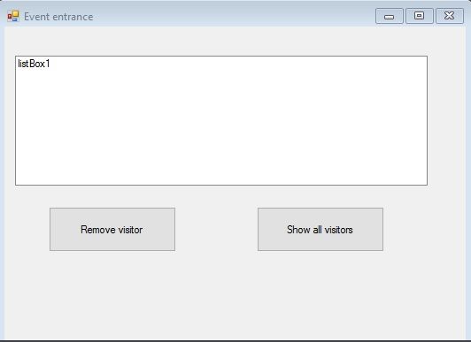

**Website GUI**:

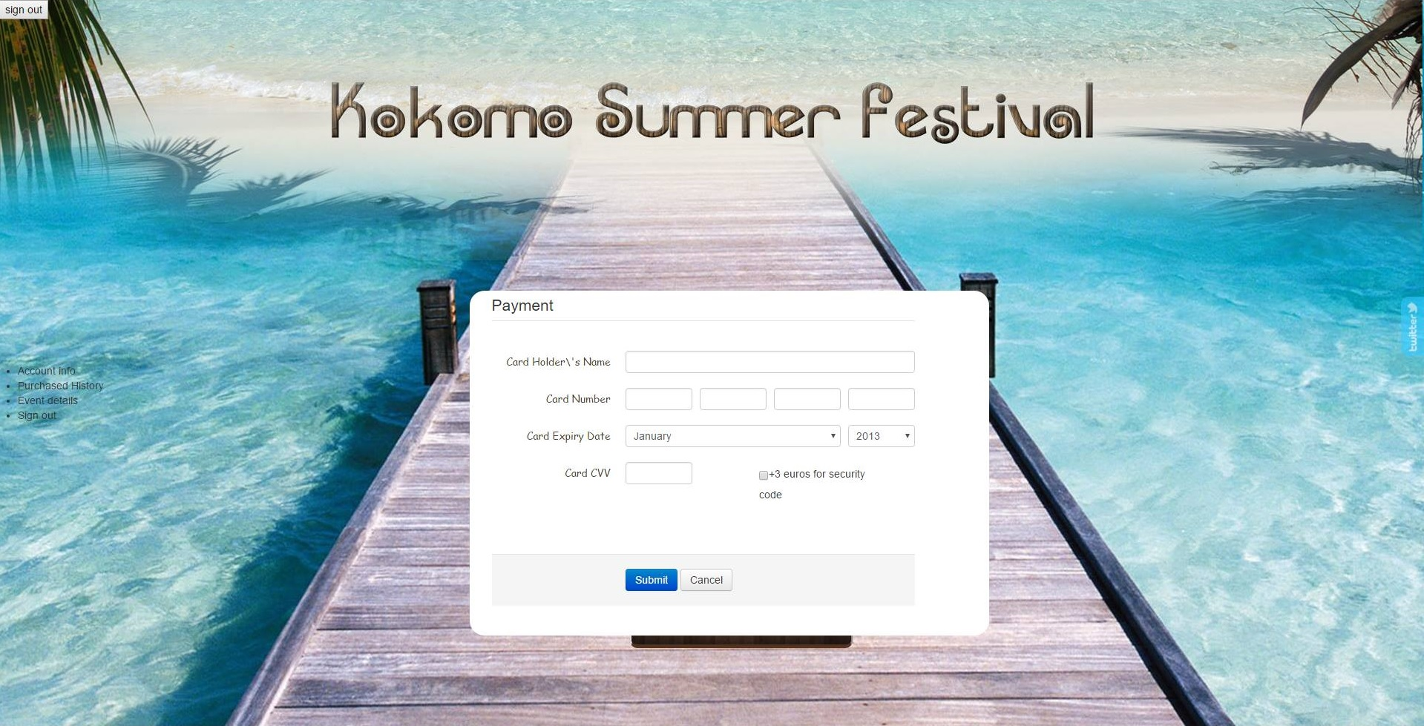

**Camping Entrance App**:

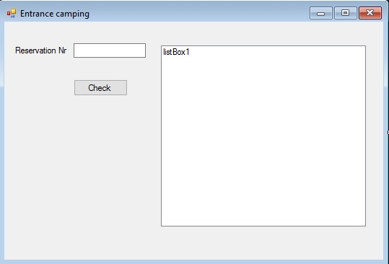

**Food & Drinks App**:

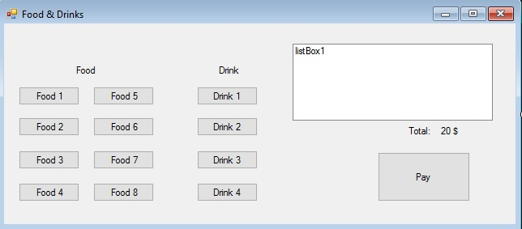

**Managers App**:

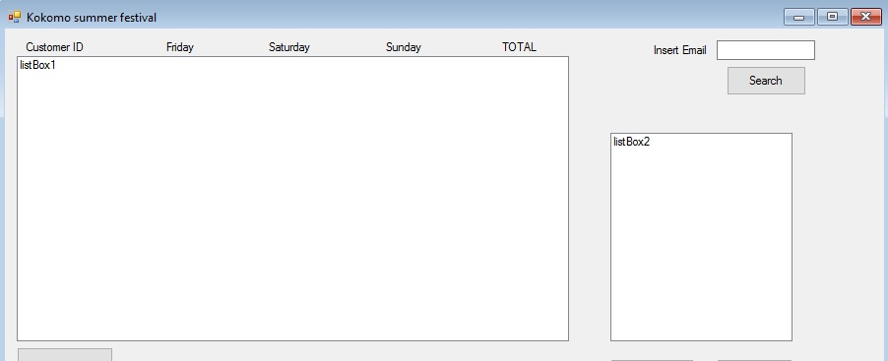

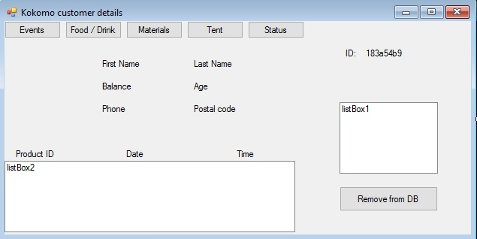

**Material Loan App**:

